Project Design Phase
Solution Architecture

Date | 15 February 2025
Team ID | [Enter Team ID]
Project Name | AI-Powered Debt Relief & Financial Recovery Platform
Maximum Marks | 4 Marks

Solution Architecture:
Solution architecture is a complex process – with many sub-processes – that bridges the gap between business problems and technology solutions. Its goals are to:
- Find the best tech solution to solve existing business problems.
- Describe the structure, characteristics, behavior, and other aspects of the software to project stakeholders.
- Define features, development phases, and solution requirements.
- Provide specifications according to which the solution is defined, managed, and delivered.

Example - Solution Architecture Diagram:


Figure 1: Architecture and data flow of the voice patient diary sample application
Reference: https://aws.amazon.com/blogs/industries/voice-applications-in-clinical-research-powered-by-ai-on-aws-part-1-architecture-and-design-considerations/

Project Solution Architecture Diagram
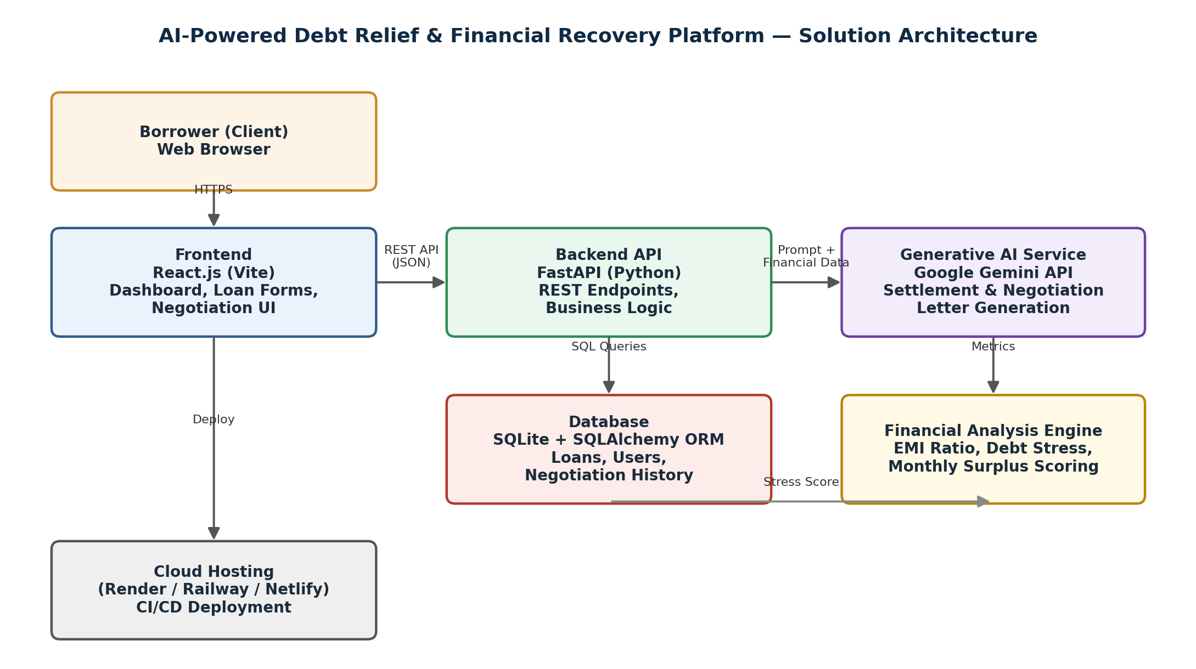

Architecture Summary
• Frontend: React.js (Vite) single-page application handling loan entry forms, the financial health dashboard, and negotiation letter display.
• Backend: FastAPI (Python) exposes REST endpoints for authentication, loan management, financial analysis, and AI orchestration.
• Database: SQLite with SQLAlchemy ORM stores users, loan records, and negotiation history; designed to be swapped for PostgreSQL/MySQL in production.
• Generative AI Service: Google Gemini API receives structured financial data and prompts to generate settlement recommendations and lender-specific negotiation letters.
• Financial Analysis Engine: A Python-based rules engine computes EMI ratio, monthly surplus, and debt stress score before any AI call, ensuring the AI receives grounded, accurate figures.
• Deployment: Frontend deployed via Netlify; backend deployed via Render/Railway, connected over HTTPS.

